Git Lab One

Jacques Sauvage

git init – Is used to create a new repository

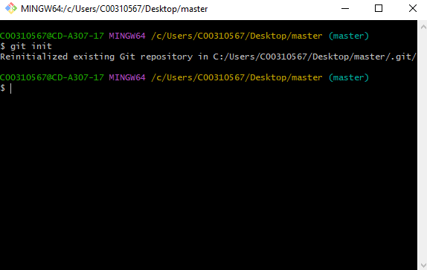

git status – this shows the new files and deleted files in that folder.

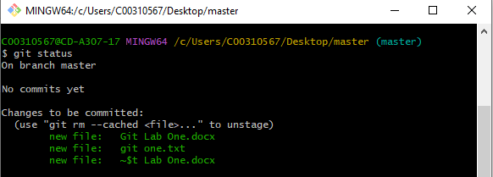

git commit = update your main branch with the progress you’ve done

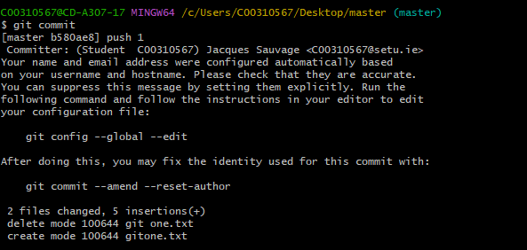

git config = shows you a list of possible commands to use for git

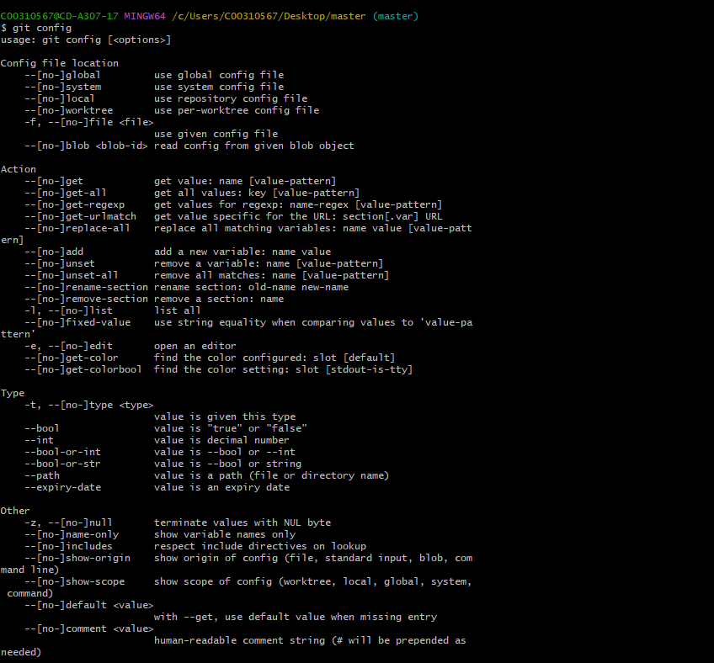

git switch = Makes the last node on this branch the current HEAD

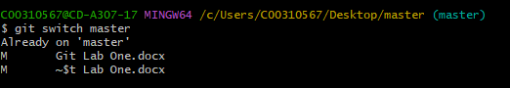

git log = Shows a history of the pushes

